Pokhara University

Level: Bachelor | Semester: Fall | Year : 2010
Programme: BE |  | Full Marks: 100
Course: Engineering Mathematics IV(appeared) |  | Pass Marks: 45
 |  | Time : 3hrs.

Candidates are required to give their answers in their own words as far as practicable.
The figures in the margin indicate full marks.

Attempt all the questions.

 | - Define harmonic function. Show that v = e^{x} (xcosy – y siny ) is a harmonic function. Find harmonic conjugate u of v.  - Evaluate 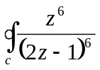dz, where c is the unit circle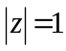, counterclockwise. | 8  7
 | - Find the expansion of 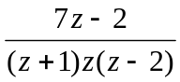 in the region given by  - 0< 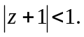  - 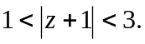  OR  State Cauchy Residue’s theorem. Use it to evaluate 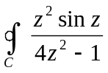 dz, where c: 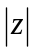 = 2 counterclockwise.  - Derive one dimensional wave equation 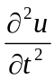 = c² 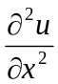. | 8  7
 | - Find the temperature in a laterally insulated bar of length L, whose ends are kept at zero temperature, assuming that the initial temperature is  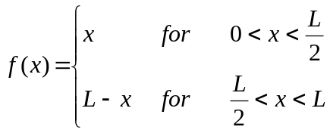  - Express Laplacian in polar co-ordinate system from Cartesian co-ordinate system. | 7  8
 | - Define z-transform. State and prove first shifting theorem on z-transform. Then evaluate Z (sinαt) and Z (cosαt).  OR  Derive Z-transform of a^{n} cosbt and a^{n} sinbt.  - Evaluate Z⁻¹ 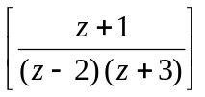. | 7  8
 | - Solve y_{n+2} – 3y_{n+1} + 2y_{n} = 0, y₀ = 0, y₁ = 1.  - Maximize z = 90x₁ + 50x₂ subject to x₁ + 3x₂ ≤ 18, x₁ + x₂ ≤ 10, 3x₁ + x₂ ≤ 24. | 7  8
 | - Find the Fourier cosine transform and Fourier sine transform of f(x) = e ^{–ax} for a>0, x>0.  - Show that 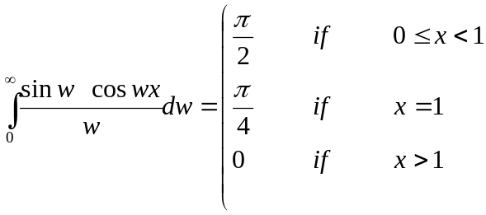 | 8  7
 | Attempt all questions  - Solve yu_{x} = x²u_{y}.  - Write the equation of ellipsoid and then sketch.  - Find the period of the function f(x) = cos 3πx.  - Find the residue of f(z) = 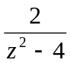 at z = 2.  - Find the real part of e^{z}. | 5×2

